RAC INCORPORATED
Craig Engel, General Contractor
1267 N 1390 W, Saint George, UT 84770 | (435) 229-7360 | racinc19@gmail.com

CHANGE ORDER CO-005
AV Panel & Smart Fixture Upgrade
Project: | Rodriguez Residence – Oak Valley Estates Lot 5 | Date: | February 25, 2026
Owner: | Mr. & Mrs. Rodriguez | CO Number: | CO-005
Location: | Liberty Lane, Kanarraville, UT 84742 | Prepared by: | Craig Engel – RAC Inc.

SCOPE SUMMARY

Item | Description | Qty | Action
Google Nest 10" Hub Panels | Remove per AV Plans A111/A112 — all locations | 11 | REMOVE / CREDIT
Axion Android PoE 8" Panel | Replace at all 11 original Nest locations | 11 | ADD
Axion Android PoE 5.5" Panel | All single gang light switching locations per electrical plan | TBD | ADD
Single Gang Smart Switch | All remaining single gang locations per electrical plan | TBD | ADD
Smart Mirror 21.5" Touchscreen | His vanity + Her vanity — Master Bath | 2 | NEW
LED Medicine Cabinet w/ Uplift | Shared vanity space — Master Bath | 1 | NEW
1. Remove Google Nest 10" Panels — All Locations [REMOVE / CREDIT]

The original AV design specified 11× Google Nest 10" Hub panels across all floors per AV Plans A111 and A112. All 11 units are removed from contract scope. A credit for removed units is applied against CO-005 additions.
Unit removed | Google Nest Hub 10" Smart Display
Count | 11 units total
Plan reference | A111 Main/Lower AV & A112 Upper AV
Contract action | Delete from scope — credit applied against CO-005

All 11 Nest panel locations on AV Plans A111 and A112 are removed. Each location is directly replaced by an Axion 8" panel under Item 2.

Removal Locations (11 total):
[̶M̶a̶s̶t̶e̶r̶ ̶B̶e̶d̶r̶o̶o̶m̶] [̶M̶a̶s̶t̶e̶r̶ ̶B̶a̶t̶h̶] [̶B̶e̶d̶r̶o̶o̶m̶ ̶2̶] [̶B̶e̶d̶r̶o̶o̶m̶ ̶3̶] [̶L̶i̶v̶i̶n̶g̶ ̶/̶ ̶G̶r̶e̶a̶t̶ ̶R̶o̶o̶m̶] [̶A̶D̶U̶ ̶M̶a̶i̶n̶] [̶A̶D̶U̶ ̶B̶e̶d̶r̶o̶o̶m̶] [̶O̶f̶f̶i̶c̶e̶] [̶L̶a̶u̶n̶d̶r̶y̶] [̶B̶a̶s̶e̶m̶e̶n̶t̶ ̶P̶a̶n̶i̶c̶ ̶R̶o̶o̶m̶] [̶G̶u̶n̶ ̶R̶a̶n̶g̶e̶]

Reference — A111 Main/Lower AV Plan:
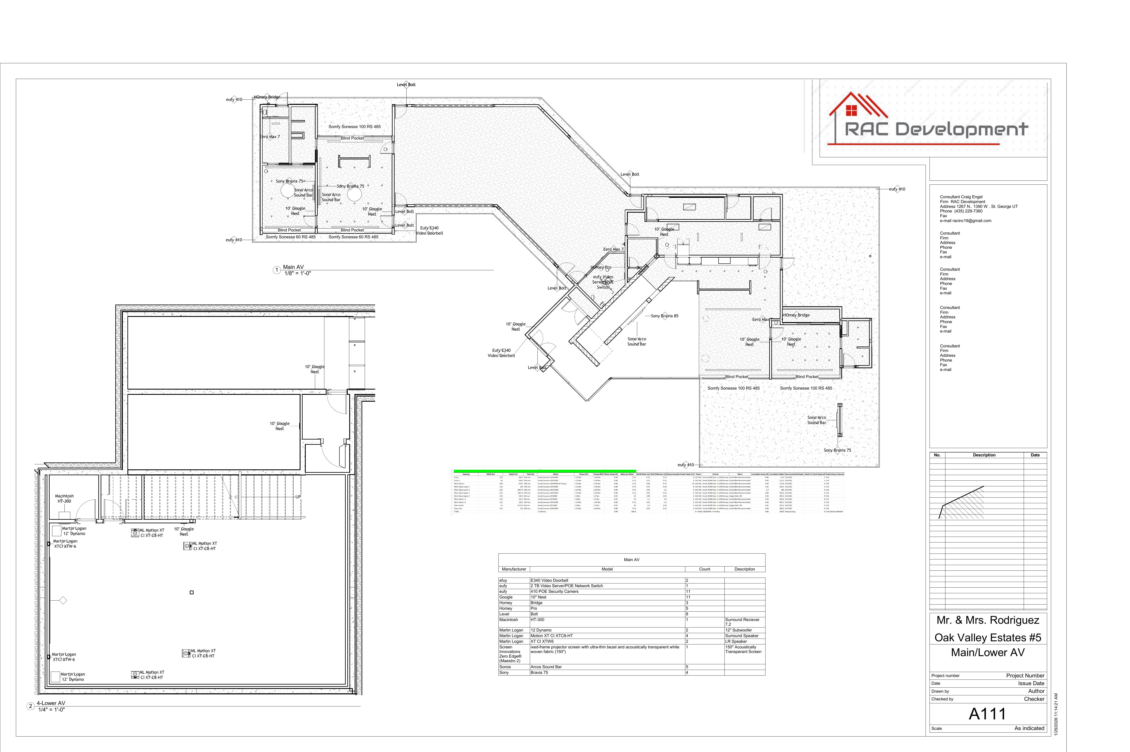

Reference — A112 Upper AV Plan:
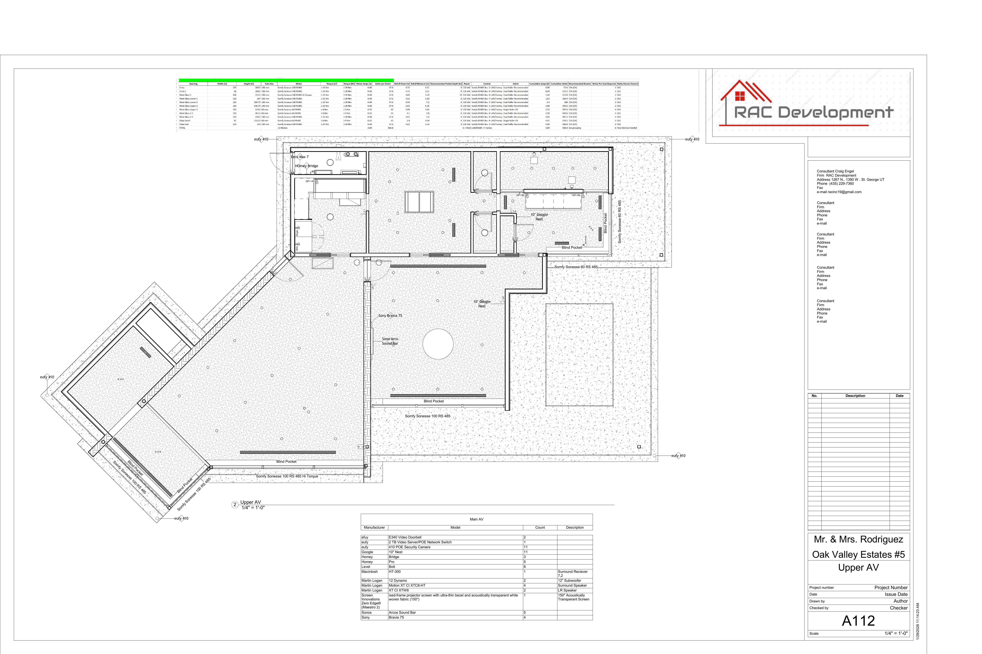
2. Install Axion Android PoE 8" Touch Panels — All 11 Nest Locations [ADD]

Product Reference — Axion Android PoE Touch Screen (8" shown):
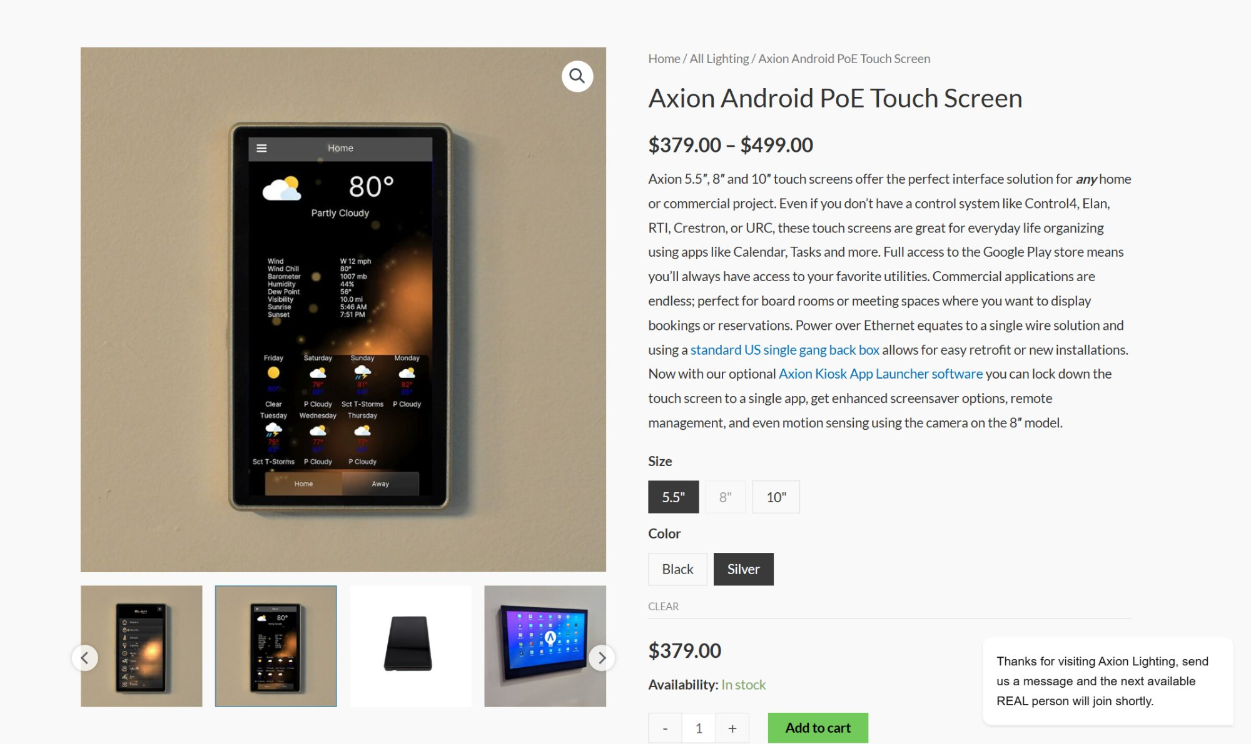

One Axion 8" panel installed at each of the 11 vacated Nest locations. Single Cat6 homerun to nearest PoE switch — no electrical rough-in changes required. Runs FullyKiosk Browser in kiosk mode locked to Homey dashboard URL. Integrated 2MP camera enables motion sensing and video calls.
Model | Axion Android PoE Touch Screen — 8"
Count | 11 units — 1:1 replacement of all Nest locations
Display | 8" IPS capacitive touchscreen
Power | PoE 802.3at — single Cat6, no separate power wire
Camera | 2MP front-facing (motion sensing via Axion Kiosk App)
Audio | 2× noise-canceling microphone + integrated speaker
OS / Software | Open Android — FullyKiosk Browser → Homey dashboard kiosk mode
Mount | US single gang back box, flush wall
Plan reference | A111 Main/Lower AV & A112 Upper AV

PoE note: Verify available ports on eufy Video Server/PoE switch and Eero Max 7 per AV plans. Add managed PoE switch to riser if additional ports required.

Installation Locations (11 total):
[Master Bedroom] [Master Bath] [Bedroom 2] [Bedroom 3] [Living / Great Room] [ADU Main] [ADU Bedroom] [Office] [Laundry] [Basement Panic Room] [Gun Range]
3. Install Axion Android PoE 5.5" Touch Panels — Single Gang Switching Locations [ADD]

Product Reference — Axion Android PoE Touch Screen (5.5" shown):


Axion 5.5" panels replace standard wall switches at all single gang light switching locations per the electrical plan. Touch interface integrates fully into Homey for scene control, dimming, and remote access. Consistent finish and UX with the 8" panels throughout the house.
Model | Axion Android PoE Touch Screen — 5.5"
Count | TBD — field verified from electrical plan
Display | 5.5" IPS capacitive touchscreen
Power | PoE 802.3at — single Cat6, no separate power wire
Audio | 2× microphone + integrated speaker (no camera on 5.5")
Housing | CNC aluminum — matches 8" panel family
OS / Software | Open Android — FullyKiosk Browser → Homey dashboard
Mount | US single gang back box, flush wall

Quantity confirmed by field walk against electrical drawings prior to procurement. All locations require Cat6 homerun to nearest PoE switch.
4. Single Gang Smart On/Off Switches — All Remaining Single Gang Locations [ADD]

Smart on/off switches added at all single gang locations not receiving an Axion 5.5" panel. Each switch integrates with Homey (Z-Wave or Zigbee) for local on/off control, remote access, and scene triggering. No standard switches anywhere in the house.
Type | Single gang smart on/off switch
Locations | All single gang locations not receiving Axion 5.5" per electrical plan
Integration | Homey Pro — Z-Wave or Zigbee
Function | Local on/off + remote control + scene trigger
Mount | Single gang, standard back box
Count | TBD — field verified from electrical plan

All single gang locations receive either an Axion 5.5" panel or a smart switch. Final per-location assignment confirmed at field walk with GC.
5. Master Bath — Smart Mirror & Uplift Cabinet Upgrade [NEW SCOPE]

Three fixtures added at master bathroom vanity. His and her vanities each receive a smart mirror with integrated touchscreen. The shared center vanity receives a motorized uplift LED medicine cabinet.

Vanity Elevation — Master Bath (Reference Drawing):
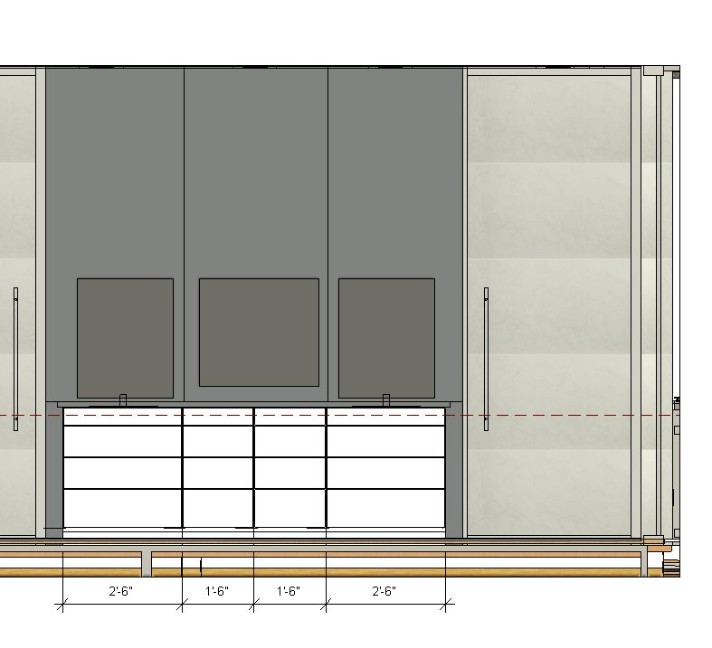

Vanity layout: His (left, 2'-6") | Shared center (1'-6" + 1'-6") | Her (right, 2'-6")
5a. His Vanity — Smart Mirror
Product Reference — Smart Mirror:
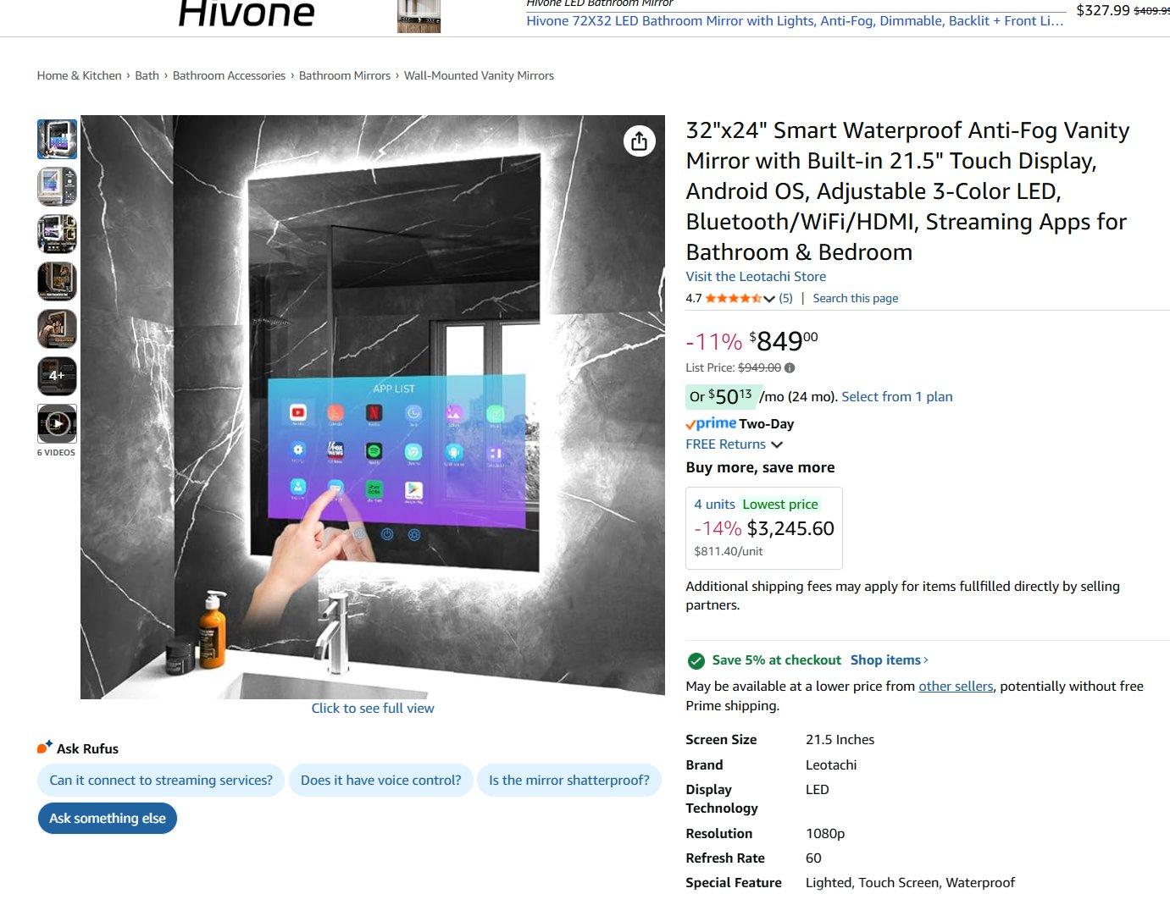

Model | Leotachi 32"×24" Smart Mirror
Display | Built-in 21.5" touchscreen — 1080p / 60Hz
OS | Android — streaming apps (Netflix, Spotify, etc.)
Features | Anti-fog, waterproof, adjustable 3-color LED backlight
Connectivity | Bluetooth / WiFi / HDMI
Location | Wall mounted above his vanity sink
Electrical | Requires dedicated 120V outlet at mirror height
5b. Her Vanity — Smart Mirror
Model | Leotachi 32"×24" Smart Mirror
Display | Built-in 21.5" touchscreen — 1080p / 60Hz
OS | Android — streaming apps (Netflix, Spotify, etc.)
Features | Anti-fog, waterproof, adjustable 3-color LED backlight
Connectivity | Bluetooth / WiFi / HDMI
Location | Wall mounted above her vanity sink
Electrical | Requires dedicated 120V outlet at mirror height
5c. Shared Center — Motorized Uplift Medicine Cabinet
Product Reference — Uplift Medicine Cabinet:
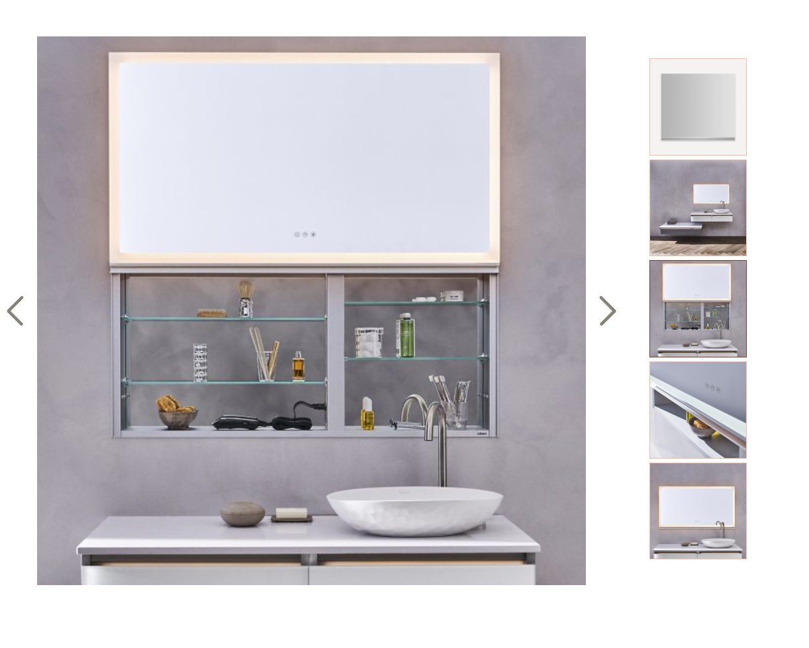

Type | LED backlit medicine cabinet with motorized uplift door
Interior | Glass shelving
Lighting | Integrated LED top panel + backlight
Controls | Touch sensor
Mount | Wall recessed or surface mount
Location | Shared center vanity section
Electrical | Requires dedicated 120V at cabinet location

Electrical coordination required: Each smart mirror and the uplift cabinet require a dedicated 120V outlet. Electrical contractor to confirm rough-in prior to procurement.

AUTHORIZATION & OWNER APPROVAL

By signing below, Owner authorizes RAC Incorporated to proceed with the scope of work described in Change Order CO-005. This change order becomes part of the contract documents upon execution. Pricing to be submitted under separate schedule.
Craig Engel — RAC Incorporated |  | Owner — Rodriguez Residence
General Contractor |  | Date: ___________________

